07 폼(form) 데이터 주고 받기

**폼(form) 데이터 주고 받기**

**미션**

사용자로부터 폼 데이터를 받고, 이를 컨트롤러에서 확인하시오.  
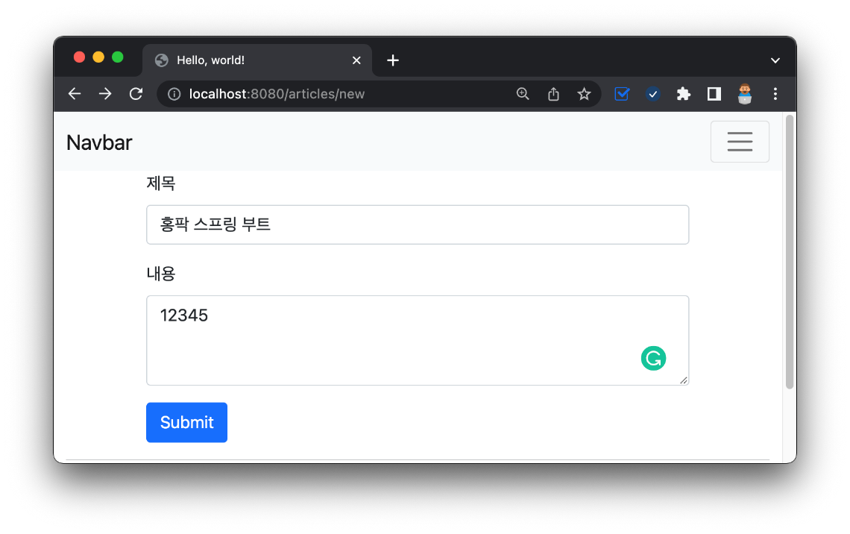

**입력 폼 만들기**

../templates/articles/new.mustache

1. {{>layouts/header}}
2. <form action="">
3. <input type="text">
4. <textarea></textarea>
5. <button type="submit">제출</button>
6. </form>
7. {{>layouts/footer}}

../controller/ArticleController

1. package com.example.firstproject.controller;
2. import org.springframework.stereotype.Controller;
3. import org.springframework.web.bind.annotation.GetMapping;
4. @Controller
5. public class ArticleController {
6. @GetMapping("/articles/new")
7. public String newArticleForm() {
8. return "articles/new";
9. }
10. }

../templates/articles/new.mustache

1. {{>layouts/header}}
2. <form class="container">
3. <div class="mb-3">
4. <label class="form-label">제목</label>
5. <input type="text" class="form-control">
6. </div>
7. <div class="mb-3">
8. <label class="form-label">내용</label>
9. <textarea class="form-control" rows="3"></textarea>
10. </div>
11. <button type="submit" class="btn btn-primary">Submit</button>
12. </form>
13. {{>layouts/footer}}

**폼 데이터 전송하기**

../templates/articles/new.mustache

1. {{>layouts/header}}
2. <form class="container" action="/articles/create" method="post">
3. <div class="mb-3">
4. <label class="form-label">제목</label>
5. <input type="text" class="form-control">
6. </div>
7. <div class="mb-3">
8. <label class="form-label">내용</label>
9. <textarea class="form-control" rows="3"></textarea>
10. </div>
11. <button type="submit" class="btn btn-primary">Submit</button>
12. </form>
13. {{>layouts/footer}}

**폼 데이터 받기**

../controller/ArticleController

1. package com.example.firstproject.controller;
2. import org.springframework.stereotype.Controller;
3. import org.springframework.web.bind.annotation.GetMapping;
4. import org.springframework.web.bind.annotation.PostMapping;
5. @Controller
6. public class ArticleController {
7. @GetMapping("/articles/new")
8. public String newArticleForm() {
9. return "articles/new";
10. }
11. @PostMapping("/articles/create")
12. public String createArticle() {
13. return "";
14. }
15. }

../dto/ArticleForm

1. package com.example.firstproject.dto;
2. public class ArticleForm {
3. private String title;
4. private String content;
5. public ArticleForm(String title, String content) {
6. this.title = title;
7. this.content = content;
8. }
9. @Override
10. public String toString() {
11. return "ArticleForm{" +
12. "title='" + title + '\'' +
13. ", content='" + content + '\'' +
14. '}';
15. }
16. }

**DTO로 데이터 받기**

../controller/ArticleController

1. package com.example.firstproject.controller;
2. import com.example.firstproject.dto.ArticleForm;
3. import org.springframework.stereotype.Controller;
4. import org.springframework.web.bind.annotation.GetMapping;
5. import org.springframework.web.bind.annotation.PostMapping;
6. @Controller
7. public class ArticleController {
8. @GetMapping("/articles/new")
9. public String newArticleForm() {
10. return "articles/new";
11. }
12. @PostMapping("/articles/create")
13. public String createArticle(ArticleForm form) {
14. System.out.println(form.toString());
15. return "";
16. }
17. }

**입력값 이름 주기**

../templates/articles/new.mustache

1. {{>layouts/header}}
2. <form class="container" action="/articles/create" method="post">
3. <div class="mb-3">
4. <label class="form-label">제목</label>
5. <!-- 입력값: title -->
6. <input type="text" class="form-control" name="title">
7. </div>
8. <div class="mb-3">
9. <label class="form-label">내용</label>
10. <!-- 입력값: content -->
11. <textarea class="form-control" rows="3" name="content"></textarea>
12. </div>
13. <button type="submit" class="btn btn-primary">Submit</button>
14. </form>
15. {{>layouts/footer}}

**🔥 구글링 훈련하기**

* HTTP GET POST 비교
* @PostMapping
* DTO란
* @ModelAttribute